**Integrating Project (PRCO204)**

**Group Title: Airline System – Group 7**

**Project Management Review Report**

1. Abstract

In this project, we are planning to develop an airline ticket booking system website due to the client’s needs. The purpose is to let users be able to view the flight information and purchase flight ticket through the online system so we want to develop the website to satisfy client for enhancing the operational efficiency.

This report will mainly evaluate the management approach of our project. It will includes discussion of application of agile, tangible artefacts etc.….

2. Evaluation of the project management approach

**Agile Development**

Agile is a term used to describe approaches to software development emphasizing incremental delivery, team collaboration, continual planning and continual learning, instead of trying to deliver it all at once near the end.

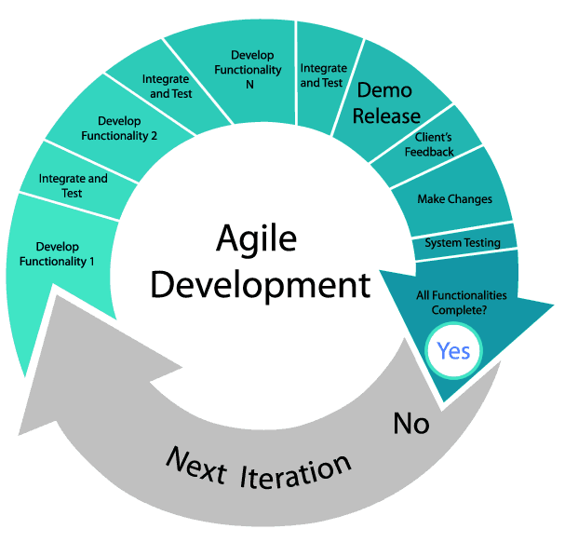

Agile development methodology has been adapted during this product development this time, as we have included the below development practices for ensuring the project is under the development cycle.

* User Story Board
* Product Vision Board
* Road Map
* Risk Analysis
* Scrum Artefacts

Product Vision Board

Product vision board was first thing to create in the agile project in order to summary the assumption about the user and the client of the system, including the client needs, business goals and the key features of the product.

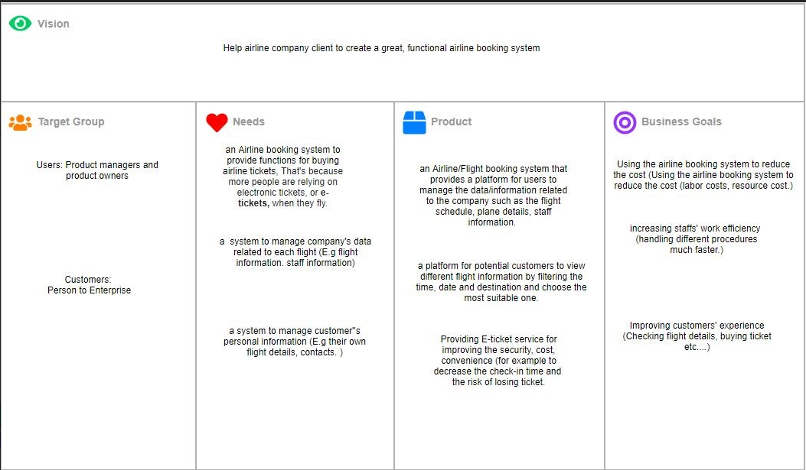

By defining a complete product vision board, it is effective for bringing out the system requirements and the product objectives.

**User Story Board**

As for providing the client with a high level view of the project, User Story board was made in the initial stage to specify all the client’s requirements for the system.

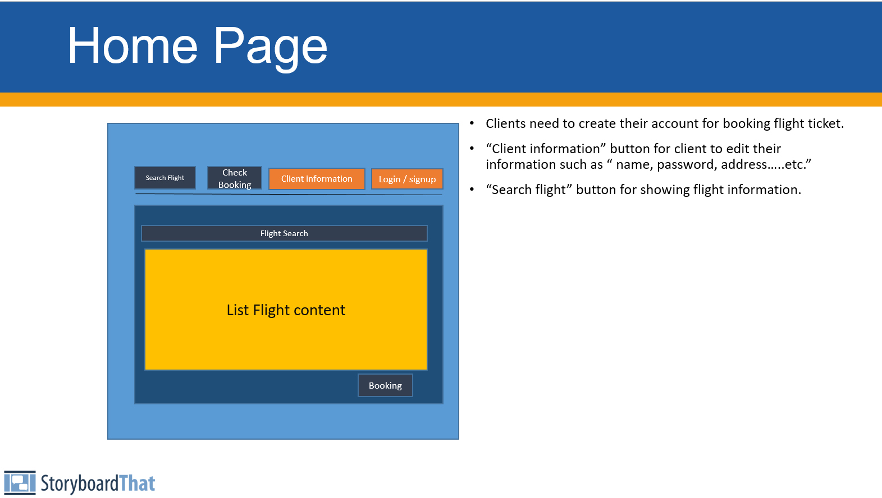

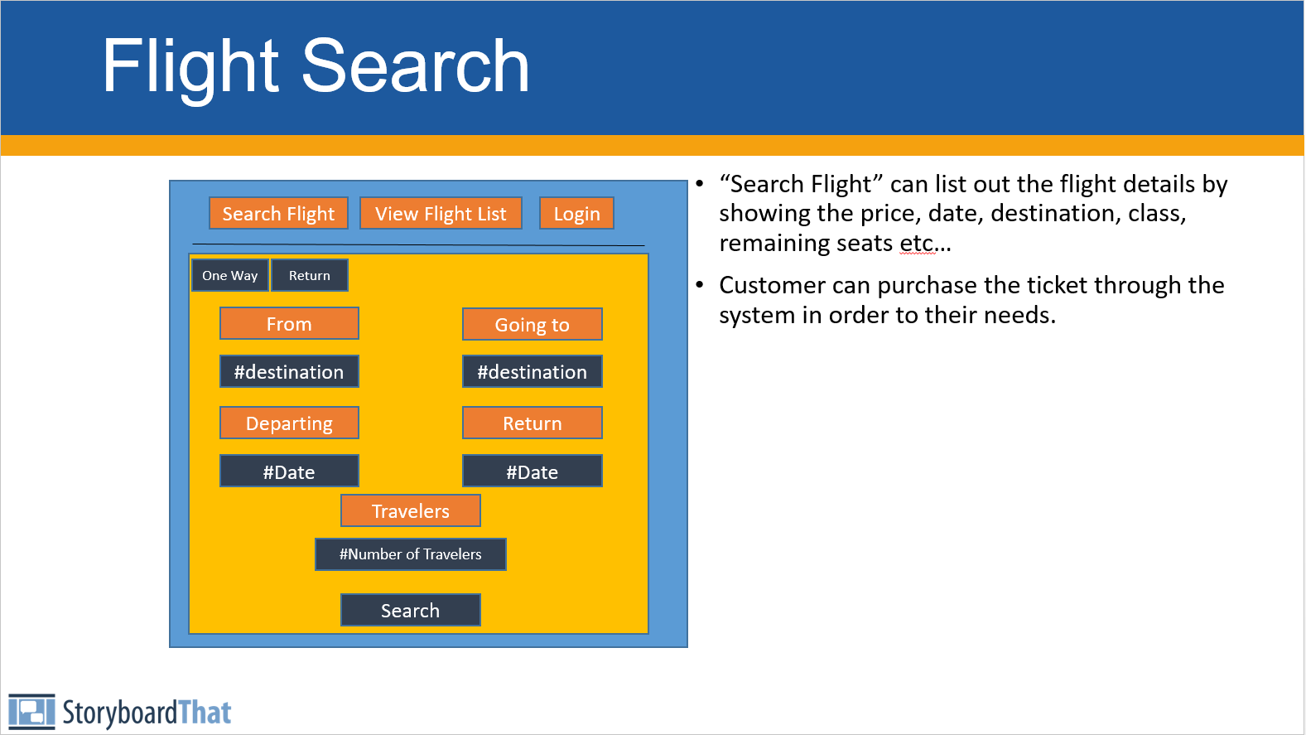

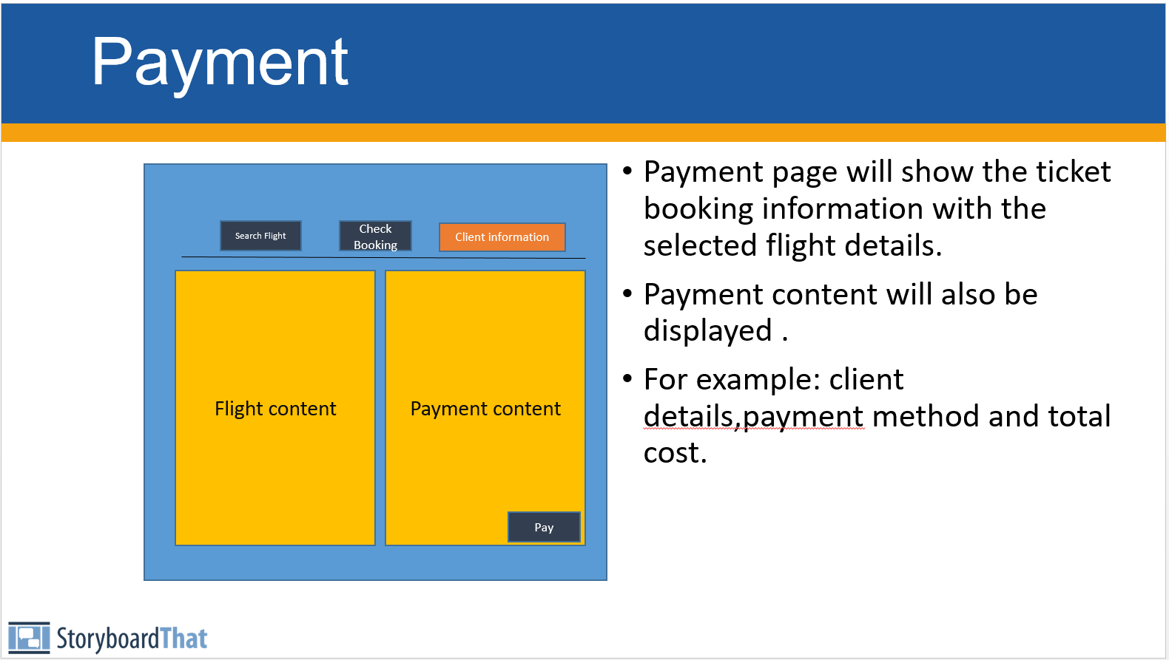

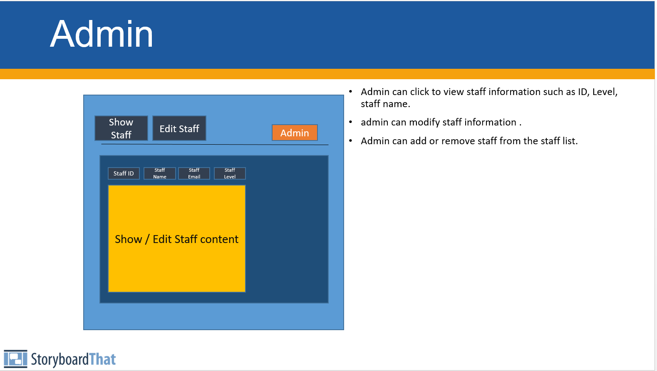

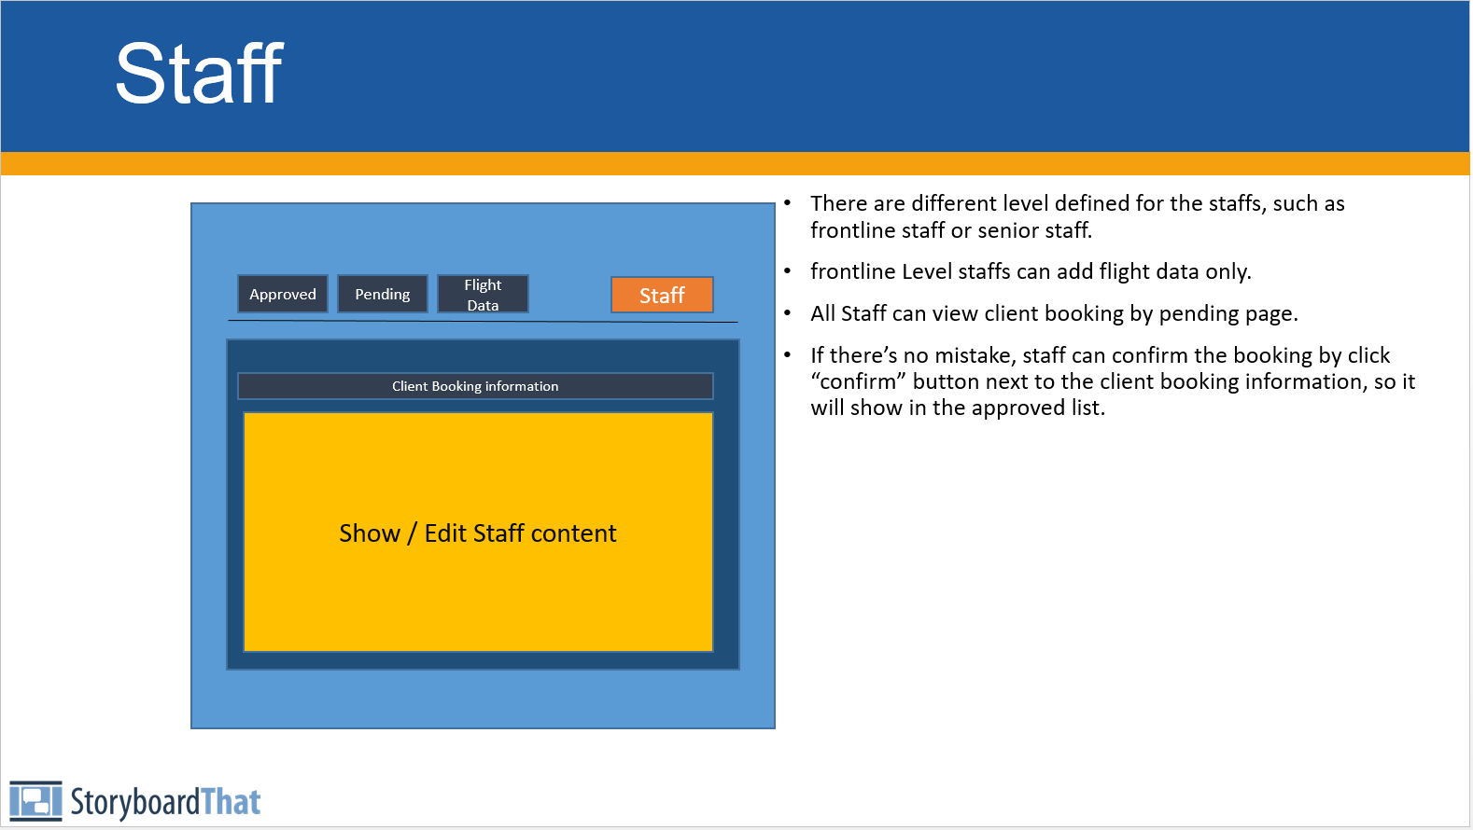

As a result, we can confirm the requirements of the system with the client by showing the user story board. (For example, Security concerns, Functional requirements, Interface Design.)

**Product Roadmap**

Product Roadmap is used to communicate the product direction of the project and progress to internal teams and clients it details the project direction and the required tasks.

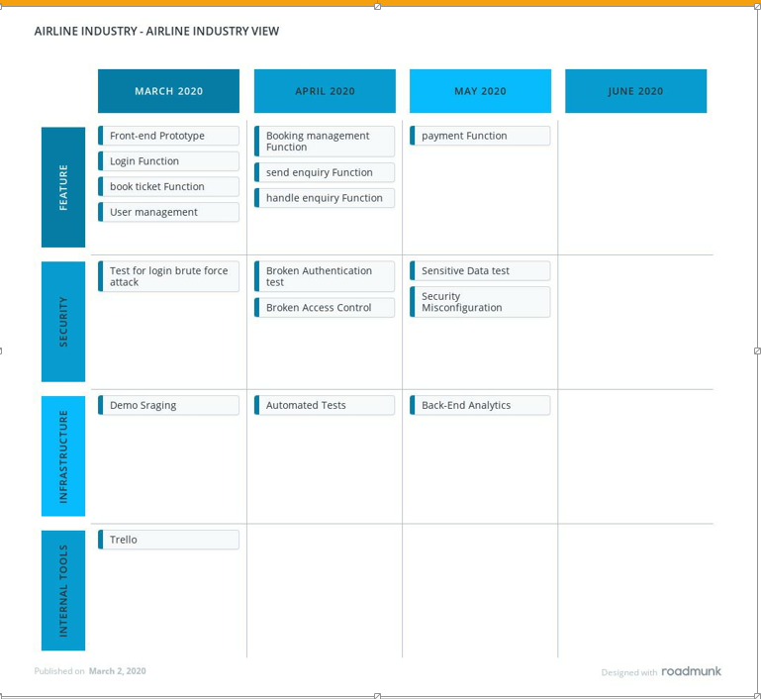

Revision of the Roadmap is needed in our team to ensure the project progress is under control and to adapt the changes of the system during an agile development cycle.

**Product Backlog & Sprint**

Product Backlog & Sprint Backlog are the important set of the scrum artefacts which are extremely helpful for the project management. For creating the Scrum board, **Trello** is the project management tool we’ve used to manage the backlogs. 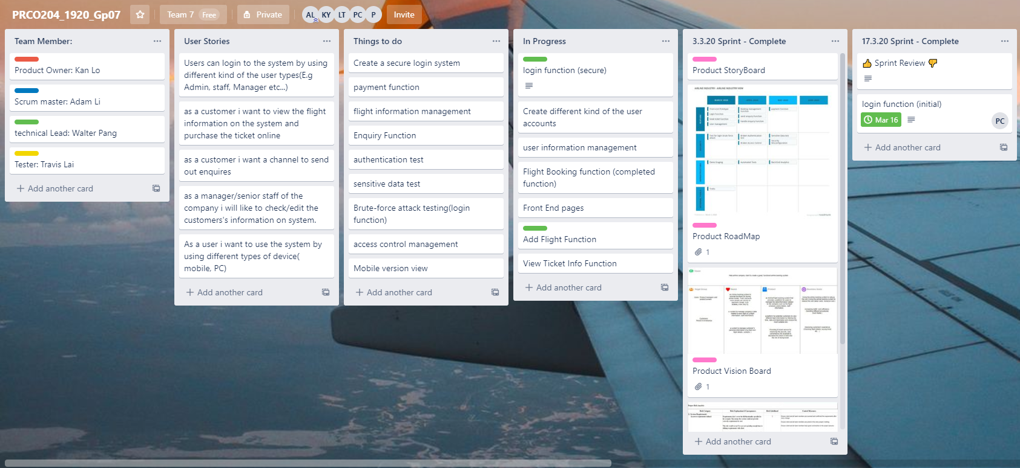

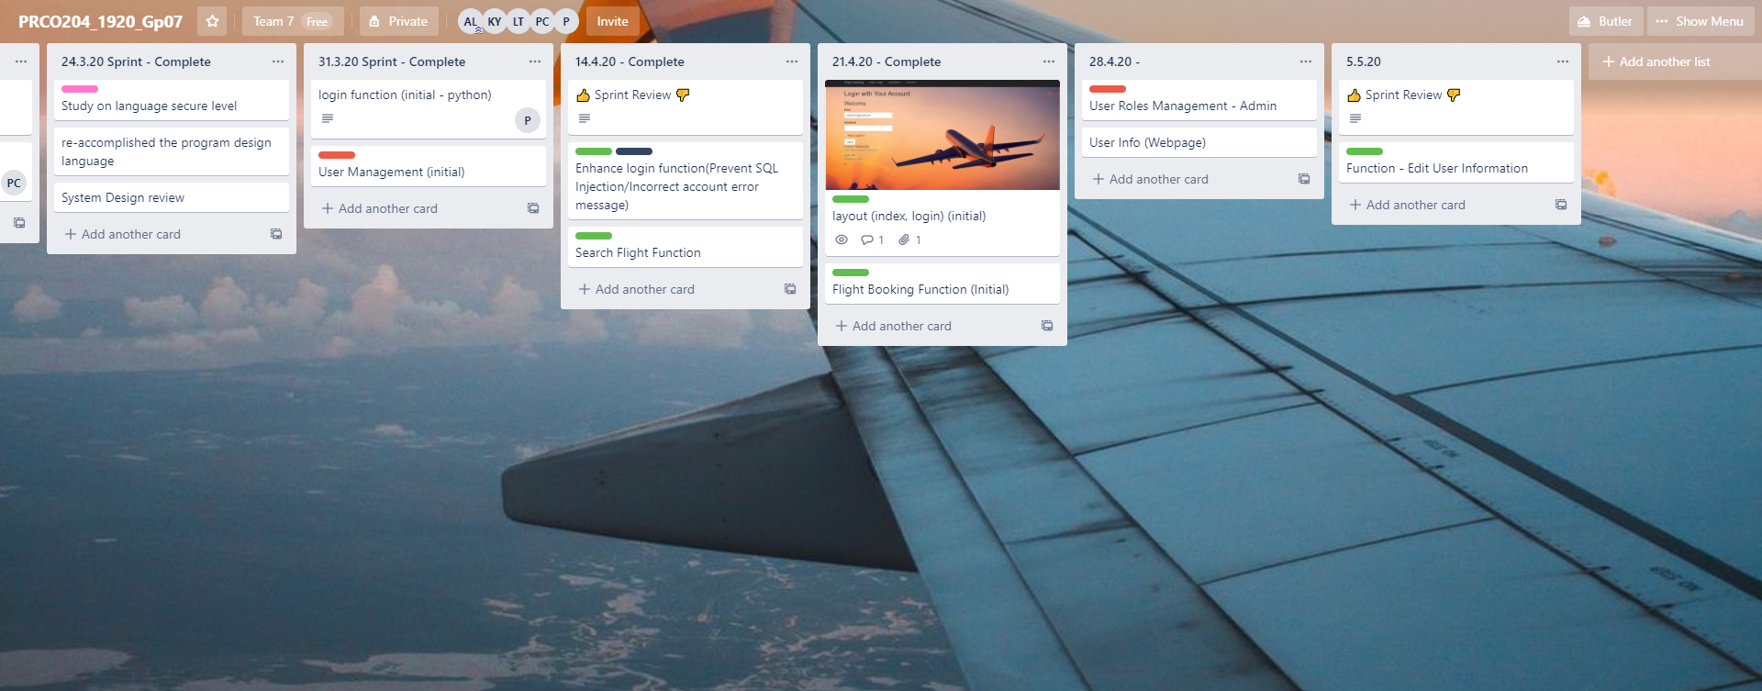

By using Trello, High efficiency for handling the product backlog,release planning and sprint backlog is one of the advantages, also we will review it weekly in order to manage the project progress such as Things-to-do-list, completed tasks, In-progress tasks and important date’s remark.

It is effective to guarantee our project progress is following the product Roadmap without a bid difference.

2. summary notes of group meetings & minutes of offical meeting with clients

**Summary notes of Group Meetings**

|  |  |
| --- | --- |
| **Date/Time:  25/2/2020** | **Duration of meeting: 60 minutes** |
| **Work done since last meeting** | |
| N/A | |
| **Topics discussed in the meeting** | |
| * Main Responsibilities for each roles * Question to be asked for the system requirements & concerns to client | |
| **Plan of work before the next meeting** |  |
| Questions to be asked for the system requirements & concerns to client | |

|  |  |
| --- | --- |
| **Date/Time:  24/3/2020** | **Duration of meeting: 60 minutes** |
| **Work done since last meeting** | |
| * Updated Product goals * Updated Product backlog * Updated Sprint backlog * Register function * login function * user account level | |
| **Topics discussed in the meeting** | |
| * Project Progress * User interface requirements * Security concerns for the system | |
| **Plan of work before the next meeting** |  |
| * Flight searching function * User information page | |

|  |  |
| --- | --- |
| **Date/Time:  31/3/2020** | **Duration of meeting: 60 minutes** |
| **Work done since last meeting** | |
| * Flight searching function * User information Page * Enhanced login function (secure login function) | |
| **Topics discussed in the meeting** | |
| * System Testing * Vulnerabilities & bugs on the system * Enhancing each functions | |
| **Plan of work before the next meeting** |  |
| * Flight ticket booking function * Enquiry Function * Admin role * Broken Authentication test | |

|  |  |
| --- | --- |
| **Date/Time:  21/4/2020** | **Duration of meeting: 60 minutes** |
| **Work done since last meeting** | |
| * Flight ticket booking function * Enquiry Function * Admin Role * Broken authentication test | |
| **Topics discussed in the meeting** | |
| * Payment function * Bug fixing tasks * Security functions to be add in the system | |
| **Plan of work before the next meeting** |  |
| * Secure the system * Payment functions | |

**Minutes of official meetings with clients**

|  |  |
| --- | --- |
| **Minutes of official meetings with clients** |  |
| Client meeting |  |
| Client: | Ivy Wong |
| Date: | 03/03/2020 |
| Time: | 30 minutes |
|  |  |
| **Attendeasd** |  |
| Walter Pang |  |
| Adam Li |  |
| Travis Lai |  |
| Kan Lo |  |
|  |  |
| **Topic discussed in the meeting** |  |
| system requirements for client |  |
| system concerns for client |  |
|  |  |
|  |  |
| **Client's Feedback If Any** |  |
| N/A |  |
|  |  |
|  |  |

|  |  |
| --- | --- |
| **Minutes of official meetings with clients** |  |
| Client meeting |  |
| Client: | Ivy Wong |
| Date: | 17/03/2020 |
| Time: | 30 minutes |
|  |  |
| **Attendance** |  |
| Walter Pang |  |
| Adam Li |  |
| Travis Lai |  |
| Kan Lo |  |
|  |  |
| **Topic discussed in the meeting** |  |
| system requirements for client |  |
| system concerns for client |  |
| using trello to manage the project progress |  |
|  |  |
|  |  |
| **Client's Feedback If Any** |  |
| be aware of the System Progress |  |
| User Interface Concerns (functions included from the home page) | |

|  |  |
| --- | --- |
| Client meeting |  |
| Client: | Ivy Wong |
| Date: | 07/04/2020 |
| Time: | 30 minutes |
|  |  |
| **Attendance** |  |
| Walter Pang |  |
| Adam Li |  |
| Travis Lai |  |
| Kan Lo |  |
|  |  |
| **Topic discussed in the meeting** |  |
| Demonstration of the flight searching function |  |
| Demonstration of the user information page |  |
| Demonstration of the flight ticket booking function |  |
| Demonstration of the enquiry function |  |
| Demonstration of the admin role |  |
| Demonstration of the broken authentication test |  |
|  |  |
|  |  |
| **Client's Feedback If Any** |  |
| need to think more about the system security issue |  |

|  |  |
| --- | --- |
| **Minutes of official meetings with clients** |  |
| Client meeting |  |
| Client: | Ivy Wong |
| Date: | 05/05/2020 |
| Time: | 30 minutes |
|  |  |
| **Attendance** |  |
| Walter Pang |  |
| Adam Li |  |
| Travis Lai |  |
| Kan Lo |  |
|  |  |
| **Topic discussed in the meeting** |  |
| Demonstration of the secure the system |  |
| Demonstration of the payment functions |  |
|  |  |
| **Client's Feedback If Any** |  |
| the final version of the system should be more secure | |
| need to completed all the functions at the final stage | |

**Prototype Software**

**Index**

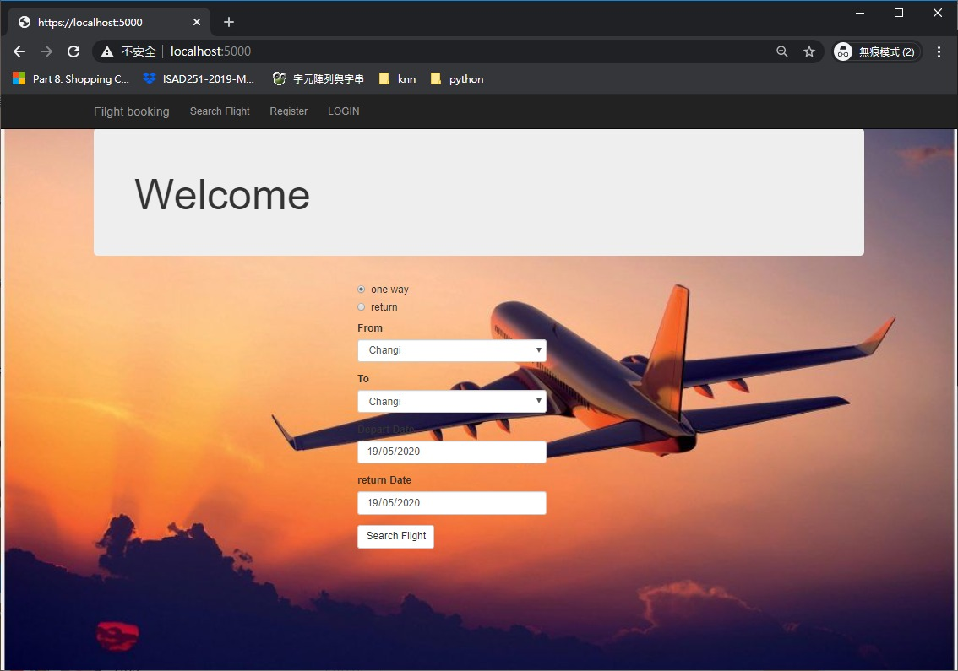

**Search flight**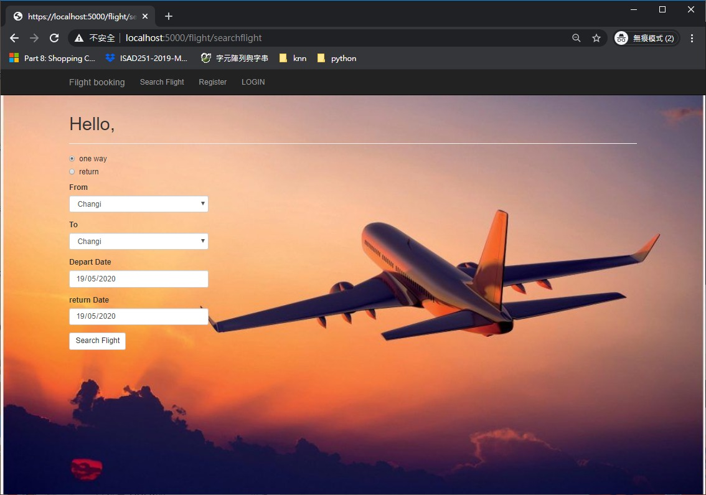

**Search result**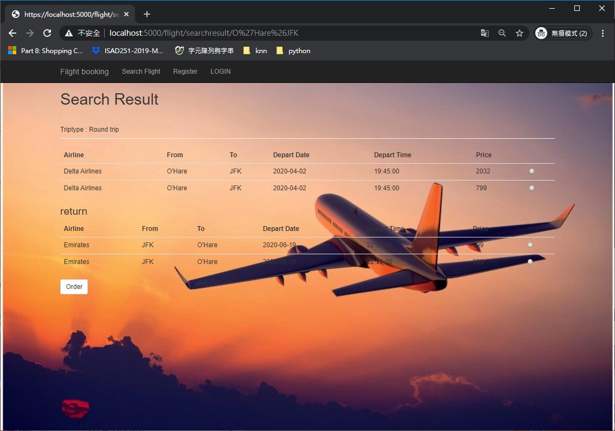

**Login page**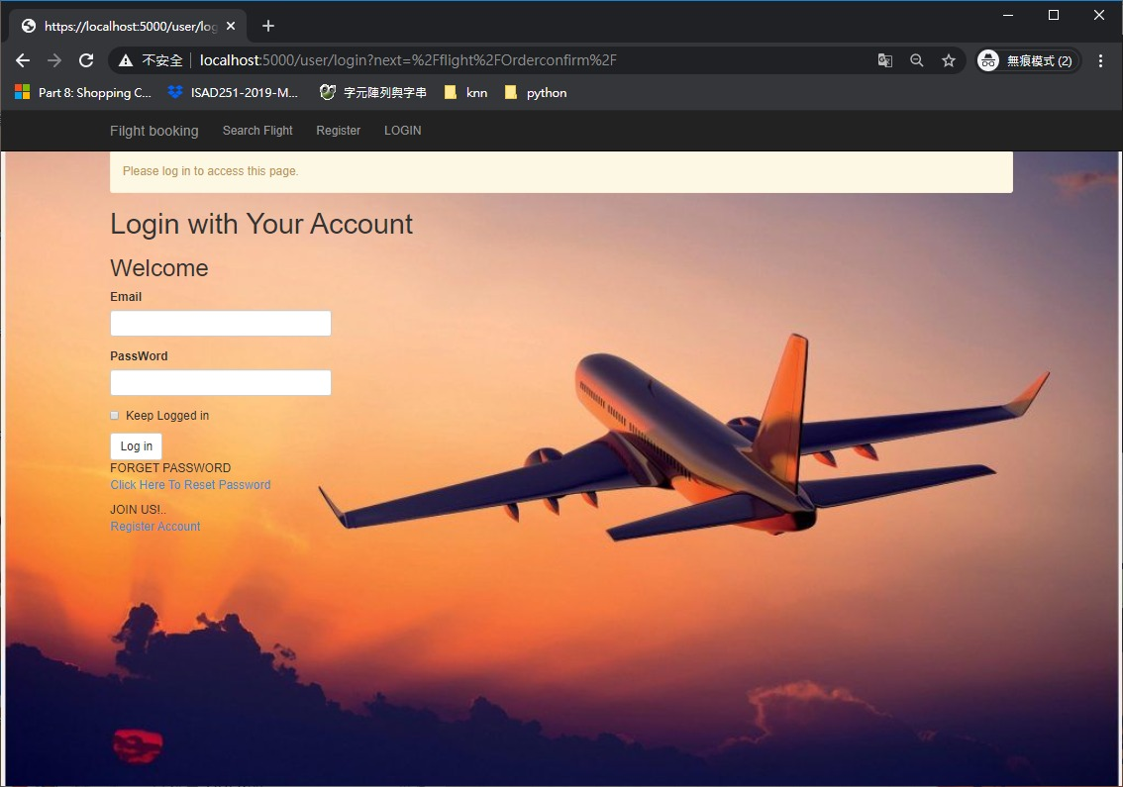

**Order confirmationPage**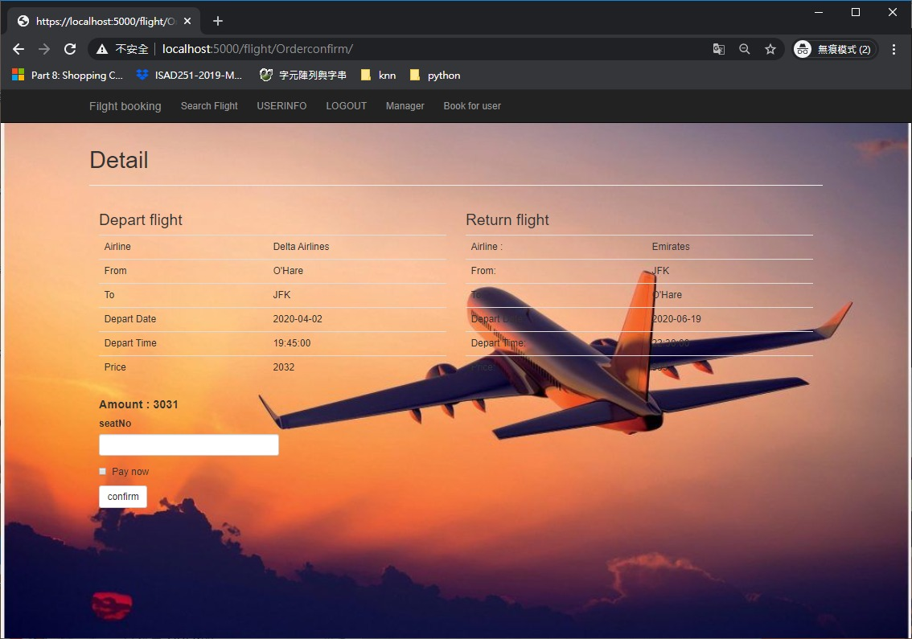

**User informationPage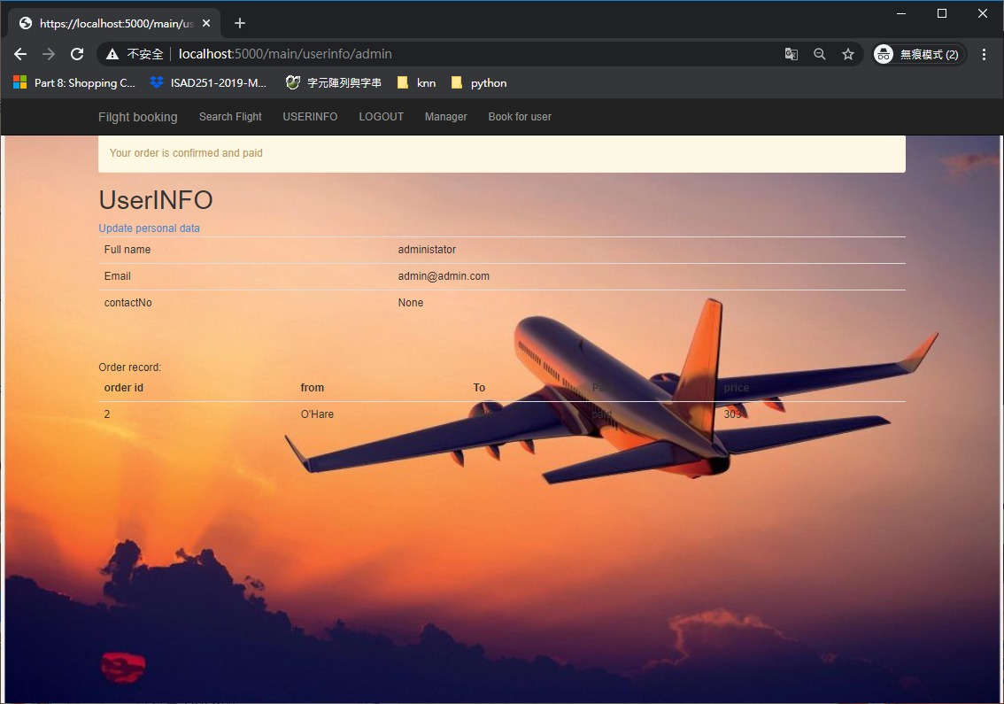ion**

**User edit information**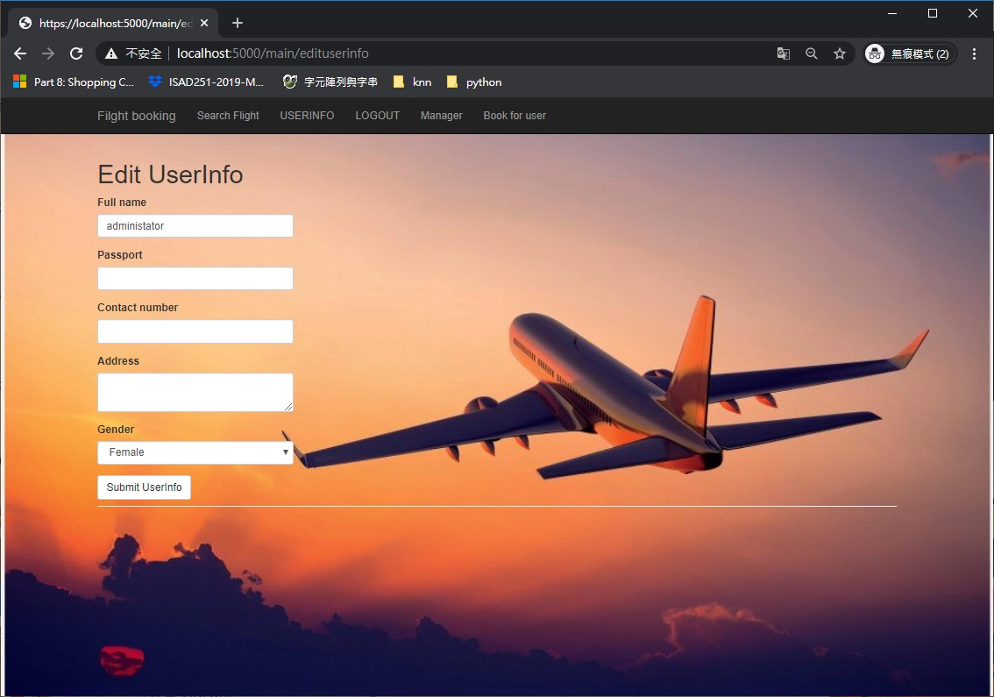

**Admin Management Page**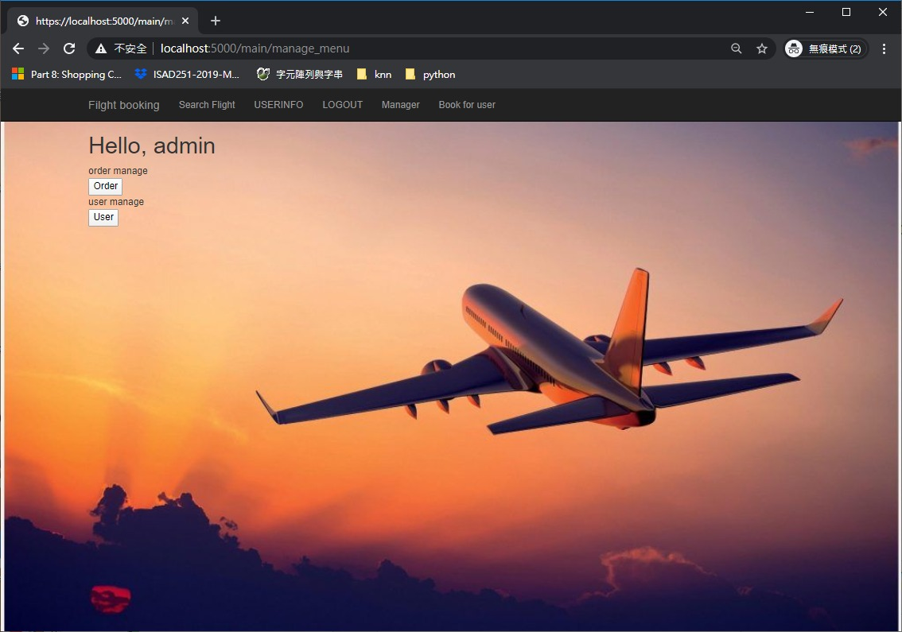

**Managing users’ orders**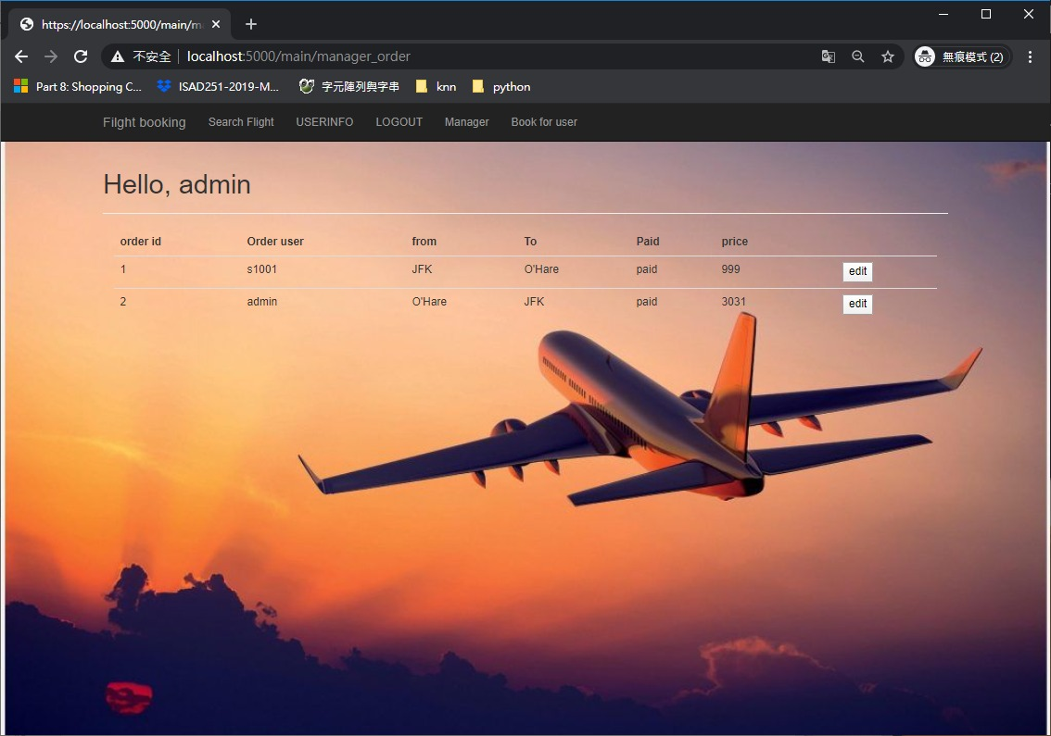

**Managing user account**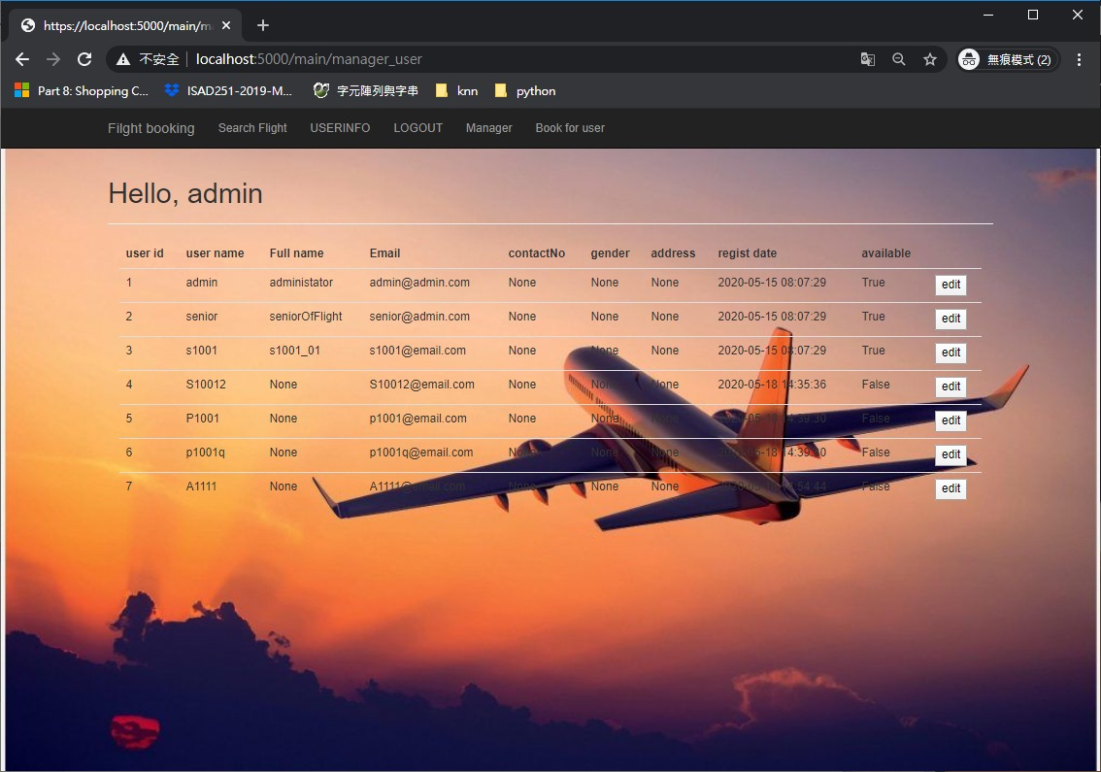

**Booking for user**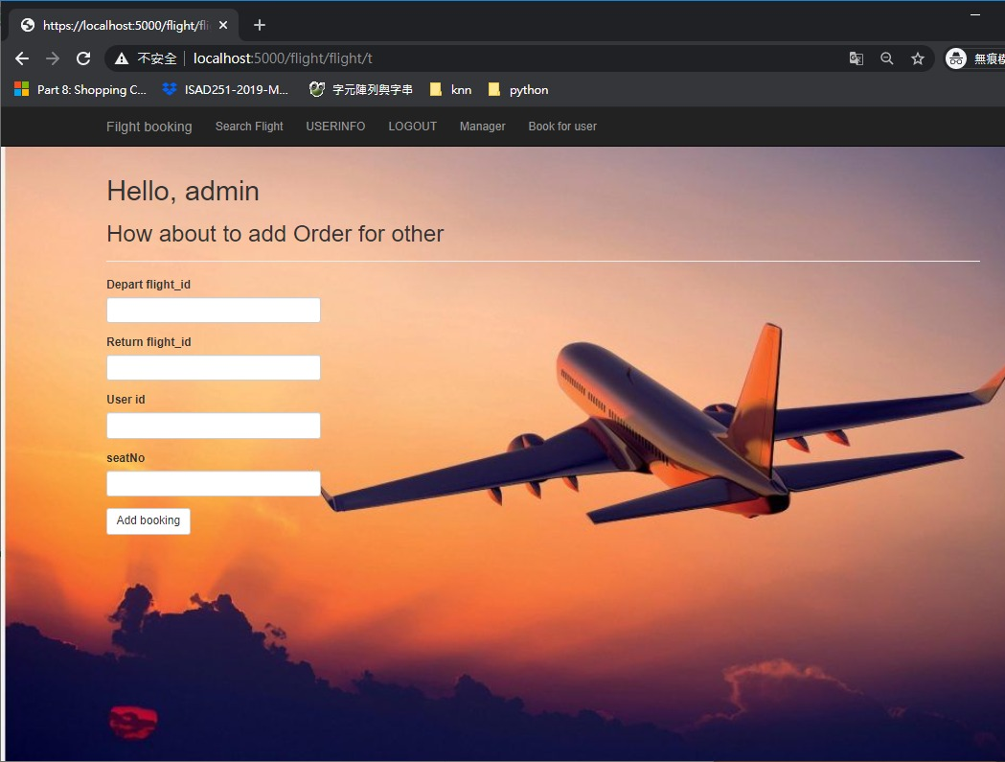

**List of software bugs and vulnerabilities**

Below are the list of software bugs / vulnerabilities

**Form Password Field with Autocomplete enabled**

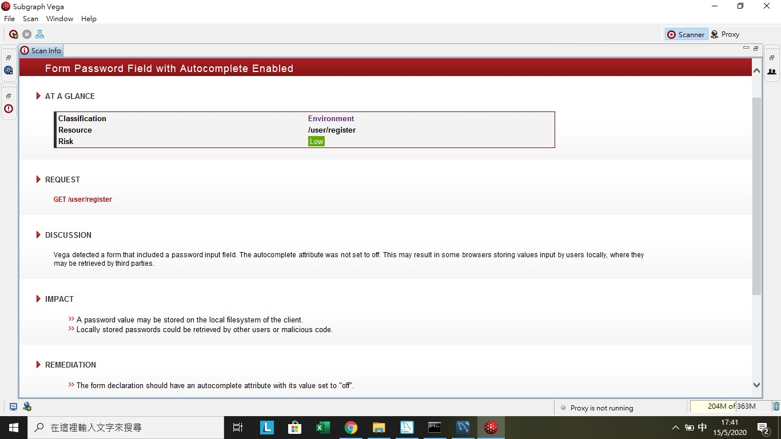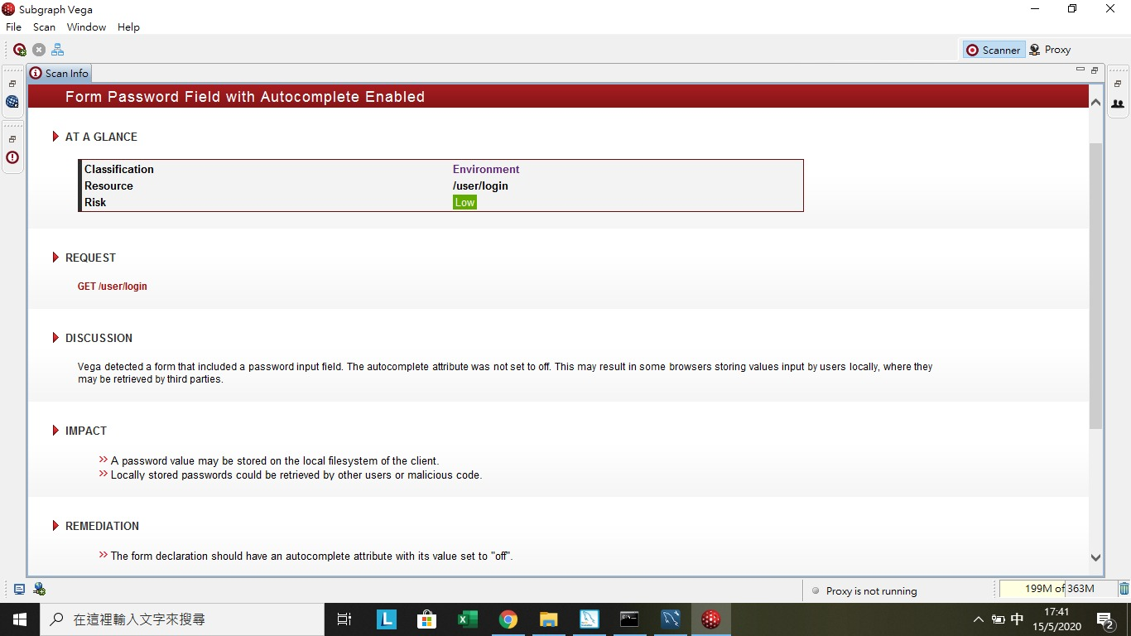

**Solution**

Add the attribute autocomplete="off" to the form tag or to individual "input" fields. However, since early 2014, major browsers don't respect this instruction, due to their integrated password management mechanism, and offer to users to store password internally.

**Cleartext Password over HTTP**

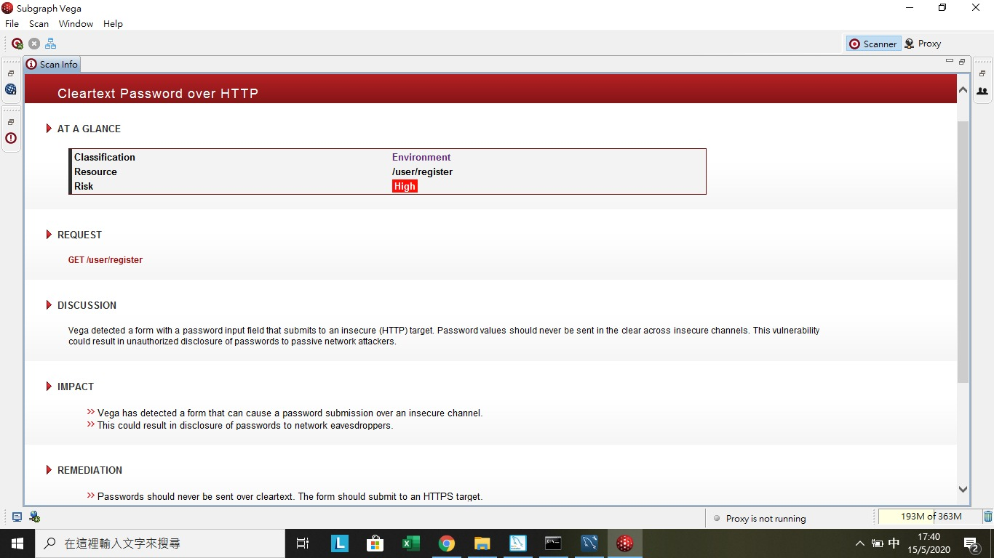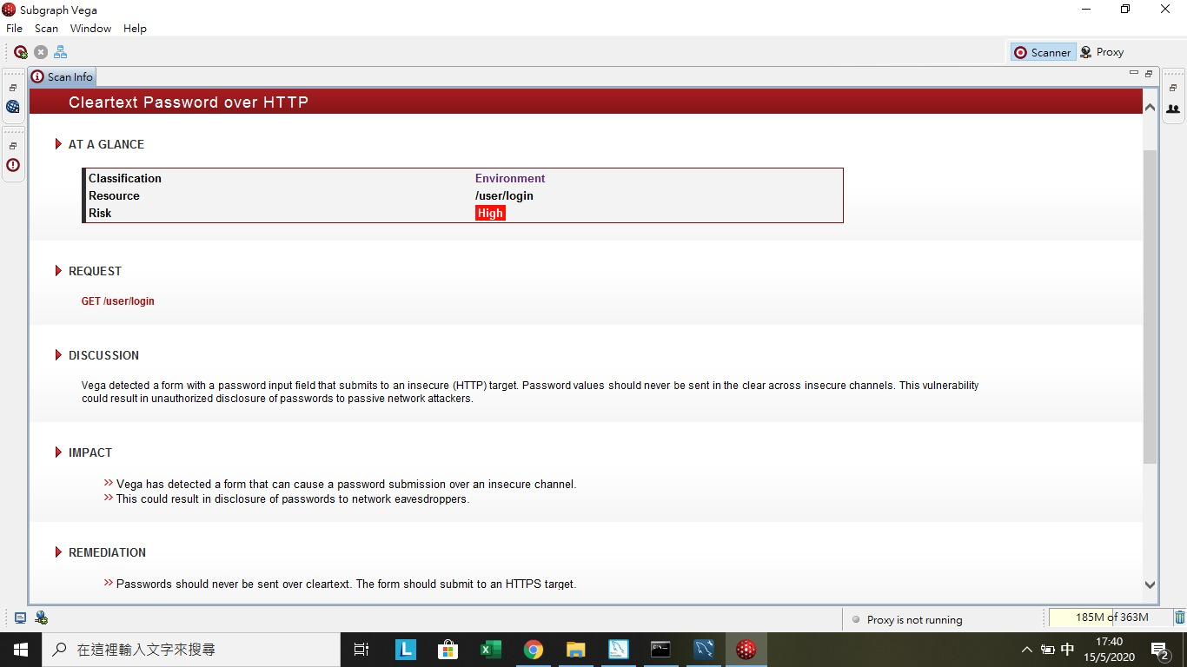

**Solution**

compile() method of Regex module makes a Regex object, making it possible to execute regex functions onto the *pat*variable. Then we check if the pattern defined by *pat*is followed by the input string *passwd*. If so, the search method returns *true*, which would allow the password to be valid.

**Used Tools for development**

**PyCharm**

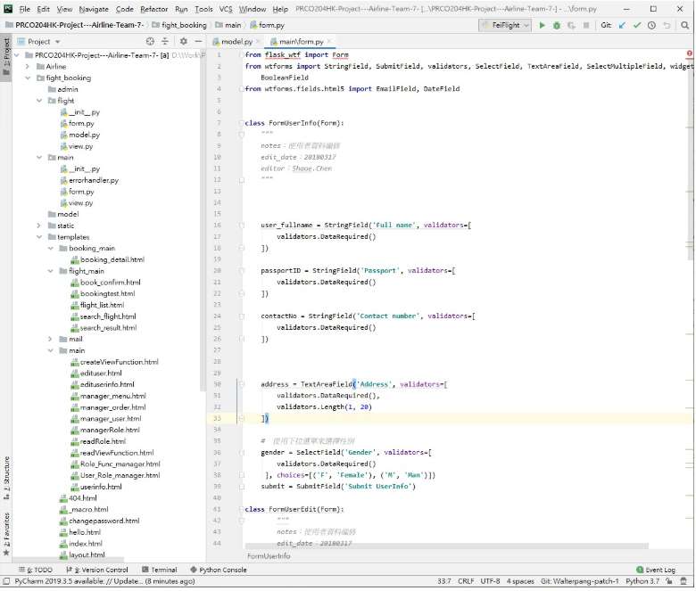

**Mysql Workbench**

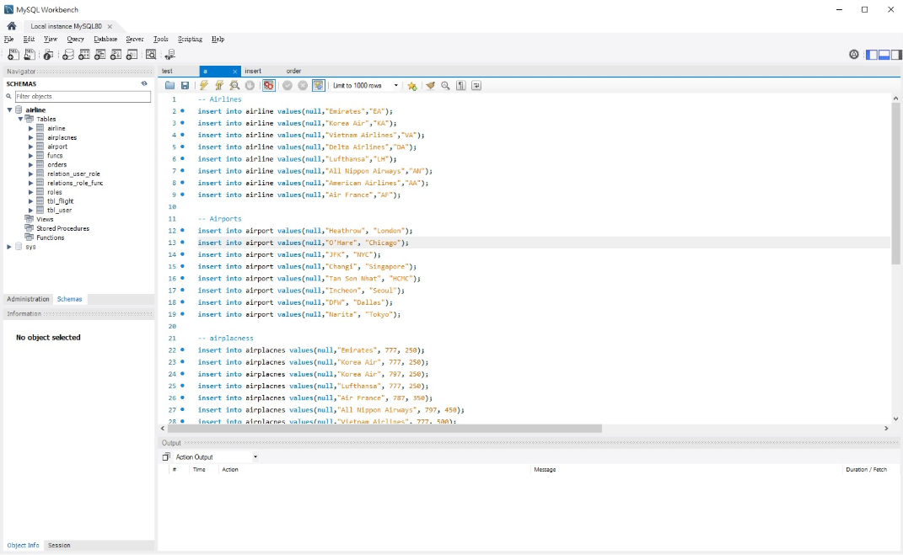

**Trello**

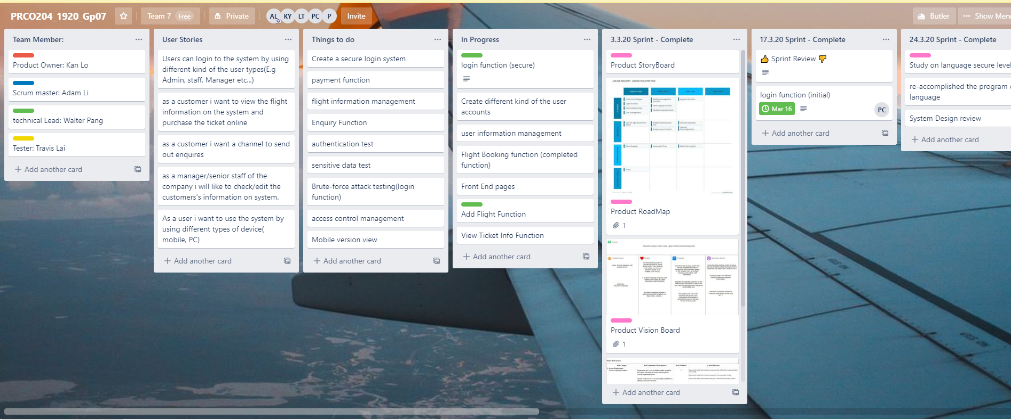

**Subgraph Vega**

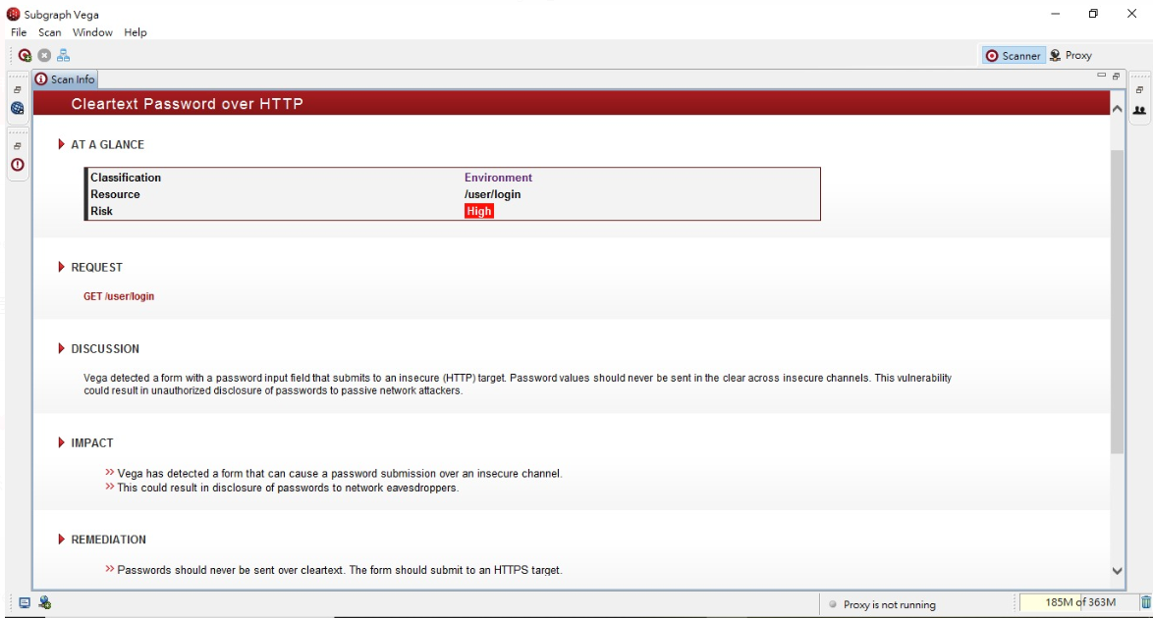

3. Active links

**Trello**

<https://trello.com/b/Luz1ZFLv/prco2041920gp07>

**Github**

**https://github.com/cpass19999/PRCO204HK-Project---Airline-Team-7-**